Building Blocks Award
1.Find in the Bible and review 3 or more of the stories listed below:
a. Noah (Gen 6-7) | b. Tower of Babel (Gen 11:1-9)
c. Abram’s tent (Gen 12:1-8) | d. Wilderness tabernacle (Ex 25-27)
e. Solomon’s temple (1 Chronicles 28:1-10, 2 Chronicles 3-5) | f. Manger (Luke 2:1-20);
g. Wise man and foolish man (Luke 6:47-49) | h. New Jerusalem (Rev. 21-22)

2. After reading the Bible stories in requirement 1, list some things that were the same and things that were different about all the building projects (materials, location, purpose, size).
Building Project from Stories | Things that were the same | Things that were different

Why was each building project built?

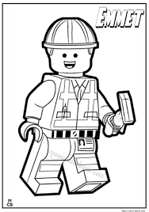

Make sure your foundation is Jesus!
3. Invite a builder or carpenter to talk about the: a. tools they use (display and demonstrate) b. kinds of things they build c. safety rules they follow d. values like being honest, measuring carefully, following instructions/plans, setting a strong foundation.

We watched a talk by a builder or carpenter on:
Tools they use:

Safety Rules:

Kinds of things they build:

Values:

4. Share 2 choices that you can make this week that will build up and not break down your character. Use the first letter of your name and surname to help you decide from the picture below. Circle your choice.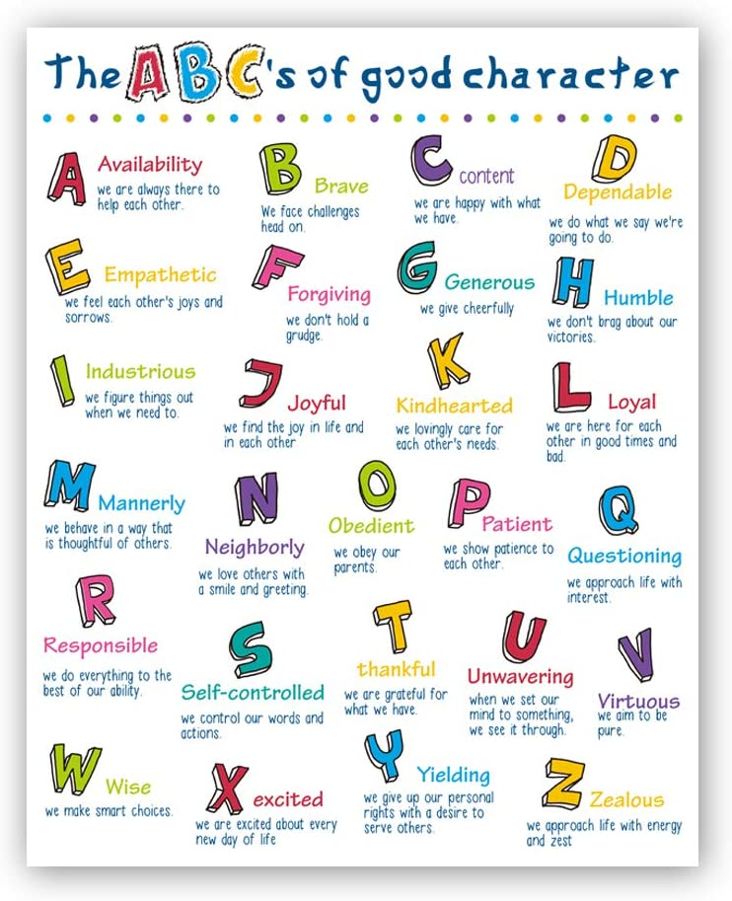
My choices are:

5. Discuss how a building and its foundation are a lot like our lives and our choices. Read & discuss 1 Corinthians 3:11 and Philippians 4:8 as part of your answer.

6. Read Revelations 21-22 a. Learn about the heavenly home that God is making for all who choose His gift of eternal life.
b. What building materials is He using? Circle the correct ones.

pearls plastic emerald paper cotton wool

gold wood sapphire jacinth topaz

jasper concrete glass amethyst chrysolite

c. Why should we wish to be in heaven?

7. Construct one or more buildings of any size or type. You may work individually or in teams. You’re your creation in a safe place and remember to take a picture and attach below.

