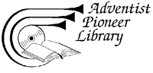
Pioneer Gallery
and Biographical Sketches
The writers on Words of the Pioneers CD-ROM each contributed greatly to the cause of the Seventh-day Adventist Church. The following brief sketches will not only reveal them as strong leaders, but as real people too. You may also wish to see the Pioneers Timelines.

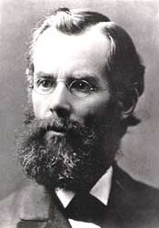 | John Nevins Andrews 1829-1883  J. N. Andrews was an intellectual who enjoyed "severe study" much more than physical activity. He was closely associated with James & Ellen White in the leadership and evangelistic work of the SDA Church.  As a theologian, Andrews made great strides in the development of church doctrines. He applied the two-horned beast of Rev. 13 to the United States of America. Further, he was influential in creating the church’s bylaws and constitution. In 1855, after thorough investigation, Andrews adopted sunset Friday evening as the beginning of the Sabbath. This began a standard for the church. He also organized the church as a legal business association, allowing the church to obtain legal possession of property. During the Civil War, Andrews lobbied for non-combatant designation for SDA draftees.  In 1860, he was involved in the organization of the denominational publishing house. The following year, he published his extensive research, History of the Sabbath & the First Day of the Week. This was a work reviewing the seventh-day Sabbath in history. Between 1869-70, he was the editor of the Review and Herald.  In 1874, he became the first SDA missionary in Switzerland. He worked to gather the scattered Sabbath-keeping companies and organize them with a united message. While living in Basel, he contracted tuberculosis and died. He was 54.  (Vol. 6, No. 2 of "Lest We Forget" features J. N. Andrews.)

Joseph Bates 1792-1872  At age 15, Joseph Bates "shipped" on a commercial vessel. For the next twenty-one years he lived the life of a sailor and ship captain. He returned to civilian life in 1828 with a small fortune. During the Advent Awakening, the retired sea captain became a respected evangelist and spiritual leader among the Adventists.  In early 1845, Bates was providentially led to an understanding of the truth concerning the seventh-day Sabbath, and in 1846 he published a 48-page tract on the subject. The respected Captain was the oldest member of our church pioneers, and he became the first Seventh-day Adventist local conference president (Michigan, 1861). He lived to the age of 80. One reason for his physical endurance, in spite of many sacrifices, was his simple diet and temperate habits. He organized of the first temperance societies in the United States. Bates was a spiritual man with clear-cut views and the courage of a lion. He did not hesitate to sacrifice when the need arose. Let us thank God for the venerable Captain -- apostle of the Sabbath truth.  (Vol. 1, No. 3 of "Lest We Forget" features Joseph Bates.) | 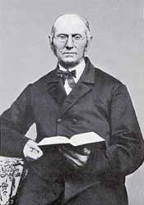

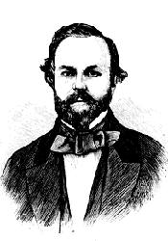 | Sylvester Bliss (1814-1863)  Sylvester Bliss was the ablest of the Millerite editors. He was first assistant editor, then editor, of the Millerite journal The Signs of the Times. He was a Congregationalist from Hartford, Conneticut, with a liberal education and was a member of the Historical Society of Boston. He was also an editor of the Advent Shield and later edited the Memoirs of Miller (1853). Among his works are Commentary on the Revelation, The Time of the End, and Analysis of Sacred Chronology. He remained until his death the editor of the Advent Herald (a later name of The Signs of the Times), which remained the organ of the group of ex-Millerites who did not accept the doctrine of conditional immortality.  (Source: SDA Encyclopedia)

Daniel T. Bourdeau (1835-1905)  Daniel T. Bourdeau was an evangelist and missionary, and brother of A. C. Bourdeau. At 11 years of age he joined the Baptist Church and at 16, with his brother, attended a Baptist French-language institution at Grand Ligne, Lower Canada. In 1861 he married Marion E. Saxby. Ordained to the SDA ministry in 1858, he, with his brother, spent many years in evangelism in New England and Canada. As far as is known, the two brothers were the first of French descent to have accepted the SDA faith.  In 1868, with J. N. Loughborough, he responded to a call from an SDA group in California, headed by M. G. Kellogg, to open SDA work in that State. When he returned to the East in 1870 he resumed work among the French-speaking people and organized churches in Wisconsin and Illinois (1873).  In 1876 he went to Europe to spend a year of evangelistic work in Switzerland, France, and Italy, and associated with J. N. Andrews in editorial work. Again in 1882, with his brother, he took up evangelistic work in Europe, working in France, Switzerland, Corsica, Italy, and Alsace-Lorraine. Altogether he spent seven years overseas. On returning to America (1888), he continued as a minister and writer, working at first for French-speaking people, and then largely for the English.  (Source: SDA Encyclopedia) | 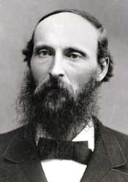

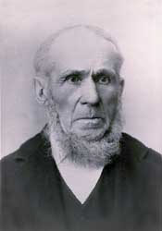 | John Byington (1798-1887)  John Byington was born in Vermont, son of a Methodist preacher who had served as a soldier in the Revolutionary army. John was baptized into the Methodist church at age 17. He shortly was given a license to preach as a lay preacher.  After moving to New York state, he helped build a house of worship for the Methodist Church around 1837 in Buck's Bridge. He became strongly involved in the antislavery movement, which eventually led to a schism in the Methodist church. John joined the new Wesleyan Methodist Church and helped to build its church building and parsonage in Morley.  In 1844 he heard sermons on the soon coming of Christ, and began studying the prophecies. In 1852 H. W. Lawrence gave him a copy of the Review and Herald containing articles on the seventh-day Sabbath. He accepted the Sabbath truth before the year was out, and was baptized. He helped then to build the first Sabbath-keeping Adventist church built for that purpose. James & Ellen White invited the Byingtons to move to Battle Creek in 1858. John bought a farm nearby, and from there would travel to minister to the scattered believers. In 1863 at age 65 he accepted the first presidency of the newly organized Seventh-day Adventist church. He worked as a genuine shepherd and pastor during his term in office. Then he returned to his farm, but continued his visitation of believers throughout Michigan for the next 22 years. "I must feed the lambs of the flock," he wrote.  (Vol. 1, No. 3 of "Lest We Forget" features John Byington.)

Merritt E. Cornell (1827-1893)  Born in New York state, and raised from age 10 in Michigan, Merritt Cornell early believed the advent message, and dedicated his life to preaching it. In 1852 he was shown and believed the Sabbath truth, and immediately began sharing it with others, J. P. Kellogg and Cornell's father-in-law, Henry Lyon, being among the first persons he met. Both accepted the Bible evidence for the seventh day sacredness.  With J. N. Loughborough during 1854 in Battle Creek he held the first Sabbatarian Adventist tent meetings. He continued to be active in evangelism, working at various times with Hiram Case, James White, J. H. Waggoner, R. J. Lawrence, D. M. Canright, and J. O. Corliss. His wife, Angeline, assisted him in evangelism. He traveled from Maine to California and to several states in the South, defending Seventh-day Adventist views of scripture in public debate, holding evangelistic meetings, and writing articles and news items about his experiences for the Review and Herald. Like Peter of old, he was headstrong and had other serious character faults, with which the Lord labored with him, sending messages through Ellen White. For some 13 years, from 1876 to 1889 he was not connected with the organized work, but continued some free-lance preaching for part of that time. In 1886 Ellen White wrote that he was "a deeply repenting man, humbled in the dust." For the last three years of his life, he was again in the ministry.  (Vol. 6, No. 1 of "Lest We Forget" features M. E. Cornell.) | 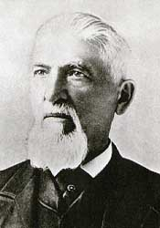

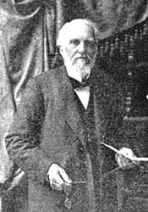 | Owen Russell Loomis Crosier 1820-1913  O. R. L. Crosier was a Millerite preacher and editor, from Canandiagua, New York. He collaborated with Hiram Edson and Dr. F. B. Hahn in publishing a small Millerite paper, the Day-Dawn. He was with Edson on the morning after the great disappointment on October 22, 1844. Edson received an inspiration from God which explained that the Millerites’ error was not in the date, but in the event; that Jesus had begun His work as High Priest in the most holy place in Heaven. Crosier, Edson, and Hahn joined together to study the subject, and Crosier was selected to write out their findings on the subject of the sanctuary and its cleansing.  Joseph Bates and James White were among those Millerites who were convinced by the resulting article. When Ellen White read the second and expanded printing of the article published in the Day-Star Extra, of February 7, 1846, she immediately recommended it to the brethren as "true light."  When Elder Bates presented the Sabbath message to a group at Edson’s, Crosier at first accepted the new light and kept the Sabbath. But eventually, he abandoned Sabbath keeping, and also his early sanctuary view.  Even though Crosier made no contribution other than the development of our early views of the sanctuary, this doctrine is unique to the Seventh-day Adventist Church. The plan of salvation is perfectly typified and beautifully explained by the services carried out in the tabernacle Moses built.  (Vol. 2, No. 1 of "Lest We Forget" features O. R. L. Crosier.)

Charles Fitch (1805-1844)  After studying at Brown University in Rhode Island, Charles Fitch began his ministry in the Congregational Church at Abington, Connecticut. In March of 1838 Fitch wrote William Miller stating that he had read Miller's Lectures and did not doubt the correctness of his views. For approximately three and a half years, he held back from preaching the Millerite message. Eventually, because he preached the doctrine of "holiness" and was exhorted not to do so, Fitch felt it necessary to separate from the established church. This separation caused him to be less influenced by the fear of man regarding the Millerite understanding of the advent.  Josiah Litch visited Fitch and told him he needed the doctrine of the second advent to add to his doctrine of holiness. Litch left him more literature to study and requested he correspond as to the result of his study. This study led to his accepting the advent doctrine.  Thereafter, Fitch traveled tirelessly, throwing himself unreservedly into proclaiming the need of preparation for the Second Coming of Christ. He moved his family to Cleveland, Ohio and held meetings and baptisms all over Ohio.  In 1842, feeling the need of an accurate chart, Fitch and Apollos Hale prepared the famous chart illustrating the fulfillment of the last-time prophecies of Daniel. This was used extensively by the Millerites. Fitch himself used this chart and also other visual aids including a replica of the Daniel 2 statue that could be separated into its various parts. Charles Fitch became seriously ill, probably with pneumonia, in the month of October, 1844. He had chilled while baptizing converts. He died on Monday, October 14th, in full faith that he should awake in a few days in the likeness of his Redeemer.  (Vol. 2, No. 3 of "Lest We Forget" features Charles Fitch.) | 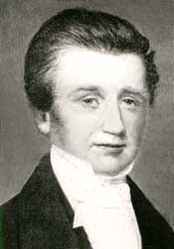

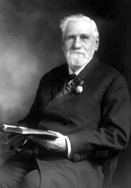 | Stephen N. Haskell (1833-1922)  Stephen Haskell was an evangelist and administrator. He began preaching for the non-Sabbatarian Adventists in New England in 1853, and later the same year began to observe the Sabbath. After self-supporting work in New England, in 1870 he was ordained and became president of the New England Conference (1870-1876, 1877-1887). In 1870 he organized the first conference Tract and Missionary Society and subsequently organized similar societies in various parts of the Eastern United States. He was three times president of the California Conference (1879-1887, 1891-1894, 1908-1911) and also of the Maine Conference (1884-1886).  In 1885 he was in charge of a group that was sent to open denominational work in Australia and New Zealand. In 1887, with three Bible instructors he began SDA work in London, England. He made a world tour on behalf of missionary work in 1889-1890, visiting Western Europe, Southern Africa, India, China, Japan, and Australia.  Another of Haskell's "firsts" was the organization of the first SDA church of African Americans in New York City (1902). He led in temperance work in Maine (1911), began printing books for the blind (1912), and assisted in the development of the White Memorial Hospital (1916). His written works include The Story of Daniel the Prophet, The Story of the Seer of Patmos, and The Cross and Its Shadow.  (Source: SDA Encyclopedia)  (Vol. 7, No. 2 of "Lest We Forget" features Stephen N. Haskell.)

John Norton Loughborough 1832-1924  J. N. Loughborough became a Sabbath-keeping Adventist through the labors of J. N. Andrews. He began preaching immediately and was ordained in 1854. He, along with D. T. Bordeau, were our first missionaries, sent to California in 1868. In 1878, he was sent to Europe. He was at one time president of the Illinois Conference. He was the denomination’s first historian, and wrote the books, The Rise and Progress of Seventh-day Adventists and The Great Second Advent Movement.  Like most of the early Advent leaders, Loughborough took a real interest in the literature work. He and James White discussed ways and means of advancing the work of the gospel. It was suggested that if books were offered to the public in connection with preaching services, the people would be willing to pay a small price for them. Thus, the way would be prepared for more literature to be produced. Young Loughborough tried this method, and it was a success.  Loughborough was truly a great pioneer, lending his many talents to the development of the work wherever there was a need.  Elder Loughborough was obedient to the heavenly vision, and God used him in a mighty way to build up the interest of His cause. Loughborough spent his last years in the St. Helena Sanitarium, where he passed away peacefully on April 7, 1924, at the ripe old age of ninety-two.  (Vol. 6, No. 4 of "Lest We Forget" features J. N. Loughborough.) | 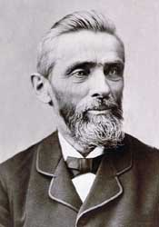

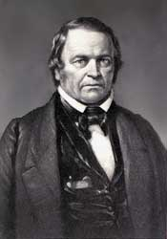 | William Miller 1782-1849  William Miller had a strong religious background, but he became attached to the wrong "crowd". His friends set aside the Bible and had vague ideas about God and His personality. When Miller was thirty-four years of age he became dissatisfied with his views. The Holy Spirit impressed his heart, and he turned to the study of the Word of God. He found in Christ the answer to all his needs. His study led him to the great prophecies that pointed to the first and to the second advent of our Lord. The time prophecies interested him, particularly the prophecies of Daniel and The Revelation.  In the year 1818, as a result of his study of the prophecies of Daniel 8 and 9, he came to the conclusion that Christ would come some time in the year 1843 or 1844. He hesitated until 1831 before he began to announce his findings. From his first public service we may mark the beginnings of the Advent movement in North America. In the months and years that followed, roughly 100,000 persons came to believe in the imminence of Christ’s second coming.  Following the great disappointment of 1844, Miller lived for several years. He fell asleep in Christ in 1849. A small chapel stands near his home in Low Hampton, New York, built by Miller before he died. In spite of his misunderstanding of the event that was to transpire in 1844, God used him to awaken the world to the nearness of the end and to prepare sinners for the time of judgment.  (Vol. 1, No. 2 of "Lest We Forget" features William Miller.)

Thomas M. Preble (1810-1907)  T. M. Preble was a Freewill Baptist minister of New Hampshire, and Millerite preacher. He accepted the Sabbath in the middle of 1844 (perhaps from Mrs. Rachel Oakes or someone else in Washington, New Hampshire). He was the first Adventist to advocate the Sabbath in print. His article in the Hope of Israel (an Adventist periodical of Portland, Maine) of February 28, 1845, was reprinted in tract form in March under the title Tract, Showing That the Seventh Day Should Be Observed As the Sabbath. This introduced the seventh-day Sabbath to Joseph Bates, who later wrote his own tract on the Sabbath. But Preble observed the seventh day only until the middle of 1847. In later years he wrote against the Sabbath in the World's Crisis (an Advent Christian paper) and in his book First-Day Sabbath.  (Source: SDA Encyclopedia) | 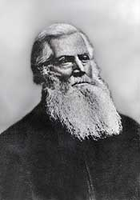

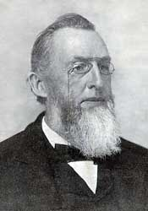 | Uriah Smith 1832-1903  In December 1852, Uriah Smith accepted the message taught by the Sabbath-keeping Adventist and soon was associated with the publishing interests of the believers in Rochester, New York. For about a half century he was the editor or on the editorial staff of the church paper, the Review and Herald. Smith was the first Secretary of the General Conference starting in 1863.  He is best known for his book, The Prophecies of Daniel and the Revelation. He was the first Bible teacher at Battle Creek College.  Elder Smith was often seen limping down the streets of Battle Creek with his cane and artificial limb, for he had suffered an amputation as a teenage boy.  W. A. Spicer gives us his impression of Uriah Smith: "As a boy I always passed Elder Smith’s editorial room in the old Battle Creek Review and Herald office with somewhat of awe: for there was a notice on the door in dark purple-colored ink and in large letters:  ‘Editor’s Room.  Busy? Yes, always.  If you have any business,  Attend to your business,  And let us attend to our business.’"  Smith was a man who was on the march. Though he was busy with the Lord’s business and he wanted others to be about theirs, he was a gracious and tender-hearted man.  (Vol. 7, No. 1 of "Lest We Forget" features Uriah Smith.)

George Storrs (1796-1879)  Born in New Hampshire, George Storrs was converted and joined the Congregational Church at the age of 19. He felt called to preach, and joined the Methodist ministry in 1825 through the influence of a godly Methodist minister. He preached much about slavery, even being arrested in 1835 while praying for the slaves during an antislavery society meeting. He was set free after a trial.  In 1837 he studied what the Bible had to say about the state of the dead after reading a tract on the subject. His conclusions led him to leave the Methodist church. In 1842 he published six sermons he had given on the topic. The same year he heard the Advent message, and began preaching the soon coming of Christ, distributing copies of his "Six Sermons" as he preached.  Charles Fitch wrote him January 25, 1844: "As you have long been fighting the Lord's battles alone, on the subject of the state of the dead, and of the final doom of the wicked, I write this to say, that I am at last, after much thought and prayer, and a full conviction of duty to God, prepared to take my stand by your side."  Storrs published a paper called "The Bible Examiner" from 1843 until he died in 1879. He did not accept the sanctuary message which explained the disappointment, nor the seventh-day Sabbath truth, but continued to believe the Bible teaching about the state of the dead.  (Vol. 1, No. 4 of "Lest We Forget" features George Storrs.) | 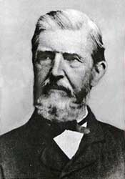

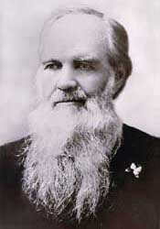 | Joseph Harvey Waggoner 1820-1889  Though a man with little formal education, J. H. Waggoner was a giant in literary accomplishments, a master of Greek and Hebrew, a knowledgeable theologian, an accomplished editor, a pioneer in health reform and religious liberty, and a tower of strength as a pioneer in the closing message of truth.  When Waggoner first learned of the Adventist message in December, 1851, he was editor and publisher of a political newspaper. Evidently Waggoner doubted that he could be saved because he had not been in ‘the 1844 movement’. Ellen White encouraged him to hope in God and to give his heart fully to Jesus, which he did then early in 1852. He threw his tobacco wad into the stove on the day he accepted the Sabbath, and he stood with Joseph Bates as a strong advocate of temperate living.  By 1853, Waggoner had unreservedly dedicated his life to the propagation of the message. Having learned the publishing trade as a youth in Pennsylvania and Illinois, Waggoner’s talents were employed many times in editorial capacities. He followed James White as editor of the western Signs of the Times, and he was the first editor of both the Pacific Health Journal and the American Sentinel (a Religious Liberty journal).  (Vol. 4, No. 4 of "Lest We Forget" features J. H. Waggoner.)

Ellen G. White (1827-1915)  Ellen Harmon was born in Gorham, Maine. Ellen and her family first heard William Miller preach in 1840. She was converted at a Methodist camp meeting that same year, and was baptized two years later.  In December of 1844, Ellen received her first vision, regarding the travels of the advent people to the city of God. The Lord called her to a life-long ministry as His messenger. She met James White in February 1845, marrying him in August of 1846.  The early years of their marriage were marked with poverty, hard work, and poor health. In 1849 in response to a message from God through Ellen, James began a publishing work, beginning with the Present Truth.  In addition to personal messages given her for specific people, Mrs. White received visions and dreams outlining the Bible truths for our time. She wrote extensively on topics as varied as the great controversy between Christ and Satan, healthful living, proper methods of education, and godly family relations. Out of these messages, the believers were led to begin schools, sanitariums, and publishing houses.  She did the bulk of her writing during the last three decades of her life. During these years she labored particularly with others to bring the message of righteousness by faith in an end-time setting to the church, and then endeavored to contain the damage that ensued when this truth was rejected.  Mrs. White's last years were spent living in California. Through times of apostasies and fires of judgment, the Lord continued to speak through her until the end, guiding, reproving, instructing the remnant church, ever pointing the sinner to Jesus and the cross, and sounding a clarion call to prepare to meet the Lord.  (Vol. 5, Nos. 1-4 of "Lest We Forget" feature Ellen White.)  Ellen White's writings are available at the Ellen G. White Estate. | 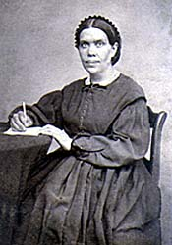

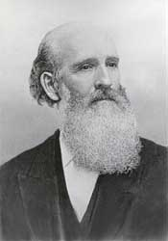 | James Springer White 1821-1881  In his youth James White was a school teacher. He later became a Christian minister in Maine. He accepted William Miller’s views on the second advent and was successful in preaching the doctrine of the soon coming of the Savior.  He was a talented and capable executive, missionary leader, and powerful public evangelist. Not only did he participate with William Miller, Joseph Bates, and scores of other preachers in announcing the advent of our Lord near in the 1840’s, but he outlived the Millerite movement to become the first great apostle of the Seventh-day Adventist cause.  White was the publisher of the first periodical issued by Seventh-day Adventists, Present Truth (1849); the first editor of the Review and Herald (1850), the Youth’s Instructor (1852), also the Signs of the Times (1874). He was president of the General Conference between 1865-1967, 1869-1871, and 1874-1880.  If there was a founder of the Review and Herald Publishing Association, it was James White along with his wife, Ellen. He was the sponsor and promoter of the Pacific Press Publishing Association.  He died August 6, 1881, when he was only sixty. He literally worked himself to death. The brethren leaned on him so heavily that his towering figure fell. His sixty years of life were spent unselfishly and sacrificially. No other Seventh-day Adventist minister did more than he to build high principle and efficiency into the life of our churches and institutions.  (Vol. 5, Nos. 1-3 of "Lest We Forget" feature James White.)

Although A. T. Jones and E. J. Waggoner are not considered pioneers, the message God gave them was "a special message", "a most precious message", "to be given to the world", "to prepare a people to stand in the day of God." It was "the matchless charms of Christ" (E. G. W. 1888 Materials, p. 43, 1336-1337, 1814, and 348). Their contribution is appreciatively noted.

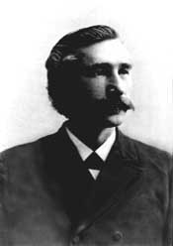 | Alonzo T. Jones 1850-1923  At age 20, A. T. Jones began three years of service in the Army. Interestingly enough, he spent much of his time pouring over large historical works, SDA publications, and the Bible. He was baptized when he left the Army, and began preaching on the West Coast. In May, 1885, he became editor of the Signs of the Times, and was later joined by E. J. Waggoner.  In 1888, these two men stirred the General Conference session in Minneapolis with their preaching on righteousness by faith. For several years thereafter, they preached on that subject from coast to coast. Ellen White accompanied them on many occasions. She saw in Jones’ presentations of "the precious subject of faith and the righteousness of Christ...a flood of light" (EGW 1888 Materials, p. 291).  Jones was on the General Conference Committee in 1897 and editor-in-chief of the Review and Herald from 1897 to 1901.  In 1889, with J. O. Corliss, he spoke against a bill in the U.S. Congress on Sunday observance; the bill was defeated. Thereafter he was a prominent speaker for religious freedom, serving as editor of the forerunner of the Liberty magazine.  After being president of the California Conference (1901-1903), he joined Dr. J. H. Kellogg’s staff against the counsel of E. G. White, a move which after a series of unfortunate misunderstandings and unwise choices, led to his separation from denominational employment and loss of church membership.  Jones remained a Sabbath observer and loyal to most of the other doctrines of the church. He is remembered especially for his part in bringing into prominence the doctrine of justification by faith.

Dr. Ellet J. Waggoner 1855-1916  In 1884 E. J. Waggoner became assistant editor of the Signs of the Times, under his father, J. H. Waggoner. Two years later, he and A. T. Jones became editors of the same journal, Waggoner remaining in the position until 1891.  At the 1888 General Conference session in Minneapolis, Minnesota, he and Jones gave their famous series of sermons on righteousness by faith.  In 1892 he became editor of the Present Truth, in England, where he lived until 1902. While there he conducted, with W. W. Prescott, a workers’ training school and, for a short time, was president of the South England Conference.  After returning to the United States, he worked briefly on the staff of Emmanuel Missionary College.  Domestic difficulties led to divorce and remarriage, resulting in his becoming separated from denominational employment. Some used this as a springboard to discredit his positive testimony on righteousness by faith, as Mrs. White once warned might happen if he were overthrown by the temptations of the enemy.  Regardless of what happened to the man, Mrs. White declared about the message, "I see the beauty of truth in the presentation of the righteousness of Christ in relation to the law as the doctor has placed it before us." MS 15, 1888. She also said, "When the Lord had given to my brethren the burden to proclaim this message, I felt inexpressively grateful to God, for I know it was the message for this time." MS. 24, 1888. | 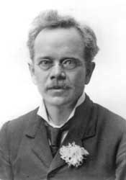

W. W. Prescott was also in the 1890's said to be one of "the Lord's chosen messengers, beloved of God" who had "co-operated with God in the work for this time" (1888 Materials, p. 1241). God gave him "a special message for the people" which he gave "in demonstration of the Spirit and power of God." (RH01/07/1896)

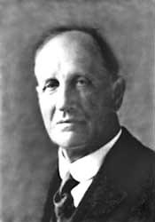 | William Warren Prescott (1855-1944)  W. W. Prescott was an educator and administrator. His parents were Millerites in New England. He graduated from Dartmouth College in 1877. He served as principal of high schools in Vermont, and published and edited newspapers in Maine and Vermont prior to accepting the presidency of Battle Creek College (1885 to 1894). While still president of Battle Creek College he helped found Union College and became its first president in 1891. Then late in 1892 he assumed the presidency of the newly founded Walla Walla College.  Because of his reputation as a Biblical scholar he was called upon to make a world tour (1894-1895) to hold Bible institutes and to strengthen developing educational interests. Back in America in 1901, he became vice-president of the General Conference, chairman of the Review and Herald Publishing Association board, and editor of the Review and Herald. On relinquishing this editorship in 1909, he edited the Protestant Magazine for seven years.  He was a field secretary of the General Conference from 1915 until his retirement in 1937, serving during this time as principal of the Australasian Missionary College (1922), and as head of the Bible department at Union College (1924-1928). He spent the year 1930 visiting the churches and institutions in Europe. On his return he wrote The Spade and the Bible, and then became head of the Bible department of Emmanuel Missionary College, a post he held until 1934.  (Source: SDA Encyclopedia)

For requests and ordering go to Feedback.

Adventist Pioneer Library
P. O. Box 1844
Loma Linda, CA 92354-0380
(909) 824-1361 (Voicemail and Fax)
Updated 27 June 2006
E-mail to apl@netbox.com

or Top of Page

