Baking
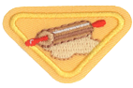

  - What is the definition for baking?
Baking is __________________food by ___________________it in an ________________at the proper
____________________.
oven cooking temperature heating

  - Describe ways to be safe in the kitchen while baking.
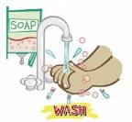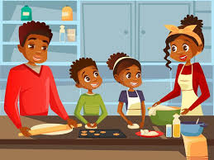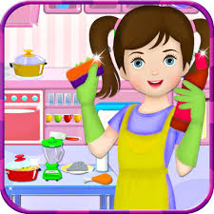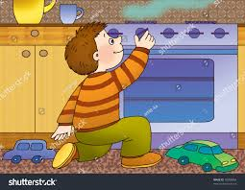
_____________________________________________________________________________________
_____________________________________________________________________________________
_____________________________________________________________________________________
_____________________________________________________________________________________
_____________________________________________________________________________________
_____________________________________________________________________________________

  - Define the following baking terms: batter, beat, coating pan, cream, dough, fold, preheat and stir.
(match terms to definitions)
Batter 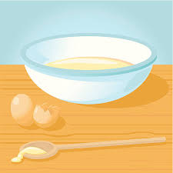 | A thick mixture of flour or meal and a liquid such as water or milk that is prepared for baking into bread, cake, or the like
Beat 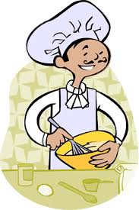 | Mixture of ingredients used in baking
Coating Pan 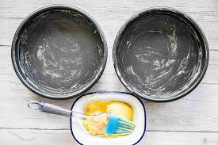 | To mix your butter and sugar(s) together until well blended, leaving you with a fluffy light-yellow mix
Cream 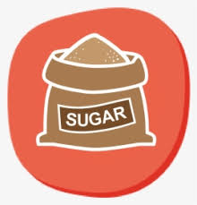 + 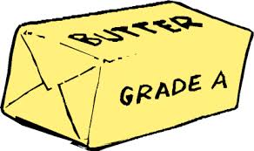 = 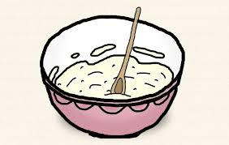 | To mix ingredients using fast circular motions. For example, to beat an egg or cake batter.
Dough 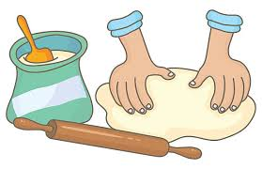 | To spread the bottom and/or sides of a pan with butter to prevent sticking
Fold 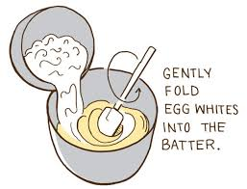 | To switch on the oven and allow it to reach a certain temperature before baking.
Preheat | To carefully combine two mixtures into one smooth mixture.
Stir 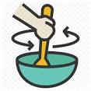 | To mix round and round with a spoon

  - Name at least 8 utensils that are used in many baking projects.
__________________________________ _________________________________
__________________________________ _________________________________
__________________________________ _________________________________
__________________________________ _________________________________

  - Read four stories in the Bible where baking was mentioned.
Genesis 18:1-13 The Three Visitors
Genesis 19:3 Sodom and Gomorrah destroyed
1 Kings 17:7-24 Elijah and the Widow at Zarephath
Other stories to read:
Leviticus 26:26, Exodus 8:3, Leviticus 7:9, Leviticus 11:35, 1 Kings 19:6, Isaiah 44:14-19, Exodus 12:39, 1 Samuel 28:24, Genesis 18:6

  - Who does Jesus say He is in John 6:35? Discuss how this is important to you.
____________________________________________________________________________________
____________________________________________________________________________________
____________________________________________________________________________________
____________________________________________________________________________________
____________________________________________________________________________________
  - Bake two items of your choosing.
Recipe suggestions:
Bread in a bag https://busytoddler.com/2018/03/make-bread-bag-kids/
Cheese puffs https://childhood101.com/cooking-with-kids-cheese-puffs/
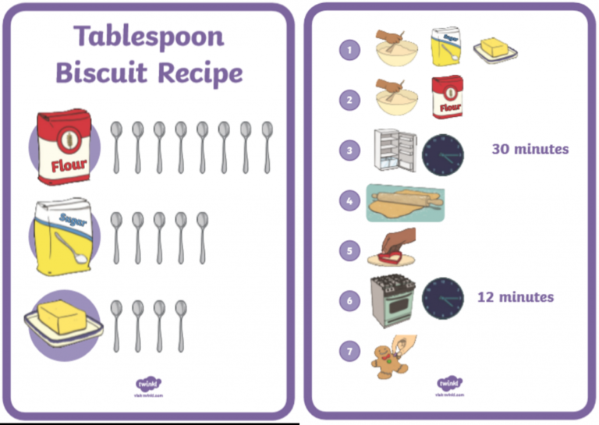

Easy Cupcakes
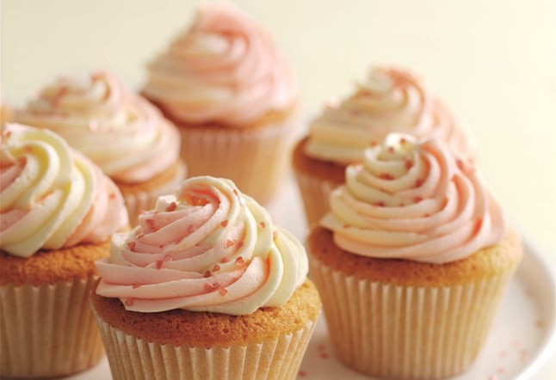
- Serves: 12
Preparation time: 45 minutes

Ingredients
- 175g butter, cut into large pieces
- 175g self-raising flour
- 175g caster sugar
- ½ tsp baking powder
- 3 large eggs
- ½ tsp vanilla extract
- For the icing:
- 175g butter, cut into large pieces
- ½ tsp vanilla extract
- 2-3 tbsp milk
- 350g icing sugar, sifted
- Pink edible food colouring
- Edible pink hearts or sprinkles for decoration

Method
- Preheat the oven to 180C/gas mark 4. Line a 12-hole muffin tin with paper cupcake or muffin cases.
- Put all the cake ingredients into a large bowl and beat with an electric hand whisk or a wooden spoon until smooth and evenly mixed. Divide the mixture evenly between the paper cases.
- Bake for 20-25 minutes, or until the cakes are well risen and firm on top. Transfer to a wire rack to cool.
- Make the icing: put the butter, vanilla extract, two tablespoons of the milk, and half the icing sugar in a large bowl and beat until smooth. Beat in the remaining icing sugar, and pour in the rest of the milk if needed to make the icing the right consistency.
- Put half of the icing into another bowl and colour it pale pink with the edible colouring. Carefully spoon this down one side of a piping bag fitted with a star-shaped nozzle, then spoon the non-coloured icing down the other side of the bag. Twist the end of the bag to seal the icing in.
- Pipe swirls of the icing on top of each cupcake. Scatter with the edible pink hearts, or other sprinkles, to decorate.

