_____________________________________________________________
Club /Church Name

____________________________________________________________
Adventurer’s Name

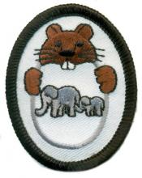

Eager Beaver
Special Families Chip
Worksheet

First family in the Bible
(Write each name in the stars)

Families in nature
(Name 5 kinds and color pictures below)
1)
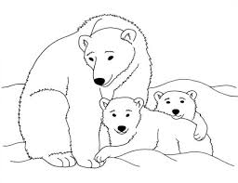
2)
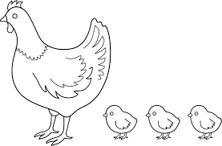
3)
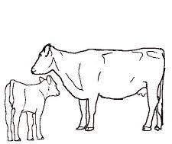

4) _____________________________________________________________________________

5) _____________________________________________________________________________

How does God provide care for these families in nature?

Name five (5) people in the Bible that did not grow up with their mother and/or/father.

1) ________________________________________________________________________

2) ________________________________________________________________________

3) ________________________________________________________________________

4) ________________________________________________________________________

5) _________________________________________________________________________

Read a story about one of these people.

Bible story (grade level): _________________________________________________________

Signature of the person who read the story: _____________________________________________

Date completed: _____________________________________________

Memorize the 5th Commandment. Give an Explanation.
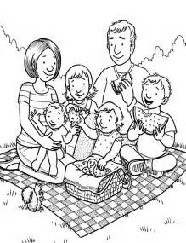

“Honor your father and your mother, that your days may be long in the land that the Lord has given you.” Exodus 20:12 ______________________________________________________________________________________________________________________________________________________ ____________________________________________________________________________________________________

